**Biome Makers, Climate FieldView, John Deere, and CNH Accelerate Digital Agriculture with Seamless Data Integration**

*New integrations combine soil biology with agronomic data to deliver precise, AI-driven ag-input product recommendations and actionable insights for optimized crop management and sustainability.*

**FOR IMMEDIATE RELEASE**

**Davis, California, March 10th, 2025**– Biome Makers, a leader in soil health and sustainable agriculture, announces integrations with Climate FieldView, John Deere, and CNH, enabling farmers to bridge the gap between soil biology and digital farming. By seamlessly connecting field data from these leading platforms with BeCrop® Farm, farmers can now access AI-driven insights into nutrient cycling, disease risk, soil resilience, and ag-input product recommendations. This integration empowers farmers with the missing piece in agriculture—biological data—providing a complete, actionable picture for more intelligent decision-making and sustainable farming practices.

**Connecting Soil Biology with Digital Agronomy**As digital tools become increasingly integrated into modern agriculture, connecting soil biology insights with agronomic decision-making platforms is key to enhancing efficiency and sustainability. By bridging this gap, Biome Makers, Climate FieldView, John Deere, and CNH are making it easier for farmers to harness biological data alongside traditional agronomic information.

“Digital agriculture is evolving toward more connected platforms, where farmers can leverage multiple data sources for better decision-making,” said Alberto Acedo, CSO and Co-founder of Biome Makers. “Our integrations with Climate FieldView, John Deere, and CNH support this transformation, making it effortless for users to bring their field data into BeCrop® Farm and unlock powerful soil biology insights, ag-input recommendations, and agronomic guidance that drive sustainable farming practices.”

**Key Benefits of the BeCrop® Farm & Digital Agriculture Platform Integrations**

* **Seamless Data Import** – Users of these three platforms can effortlessly import their field data into BeCrop® Farm to gain science-backed soil health insights—without the hassle of manual data entry.
* **Actionable Soil Health Intelligence** – BeCrop® Farm analyzes over 1,000 biological and environmental parameters to provide recommendations on nutrient cycling, disease risk, soil resilience, ag-input products, and agronomic strategies that help farmers optimize soil performance and input efficiency.
* **Data Privacy & Ownership** – Farmers retain complete control over their data, choosing when and with whom to share it. Biome Makers ensures that all data handling complies with the highest agricultural privacy standards.

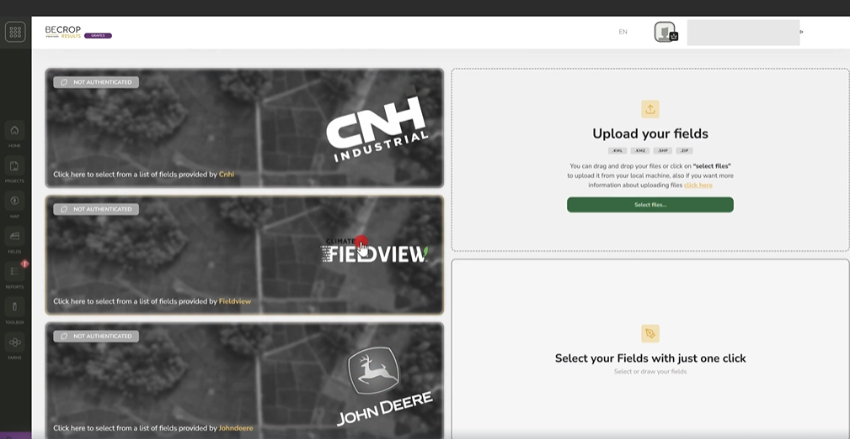

**Start Connecting Your Soil Data Today**With these new integration partners, **users can now connect their field data to BeCrop® Farm and unlock deeper soil intelligence to improve productivity and sustainability.** By making soil biology insights more accessible within digital farming workflows, Biome Makers is helping farmers **enhance efficiency, reduce environmental impact, and build resilience for the future.**

Unlock your soil’s potential. Visit [biomemakers.com/becrop-farm](http://biomemakers.com/becrop-farm)

For media inquiries and collaboration opportunities, please contact:Sarah Basiri  
[marketing@biomemakers.com](mailto:marketing@biomemakers.com)

**About Biome Makers**

Founded in the Bay Area of California in 2015, Biome Makers is one of the foremost global AgTech leaders, setting the standard in soil health with BeCrop® technology. Built on industry-leading soil microbiome and machine learning expertise, Biome Makers connectsoil biology to agricultural decision-making to optimize farming practices and reverse the degradation of arable soils. With labs across the globe, customers on 6 continents, and 2.2M+ acres of land impacted, Biome Makers revitalizes soil functionality and agricultural sustainability worldwide. For more information, visit<https://biomemakers.com/>

##########